**FLAVORS**

***FLAVORS***

Introduction …………………………………………………………………………………………

Acknowledgment………………………………………………………………………………….

Requirements……………………………………………………………………………………….

E-Project Analysis…………………………………………………………………………………..

User Guide……………………………………………………………………………………………

Coding………………………………………………………………………………………………….

**SUBMITED BY**

* **Uzair Hashmi**
* **Anas Ahmed Khan**
* **Burhan Saifuddin**
* **Osama Ahmed Khan**

Of batch **PR-2023-05G** have successfully completed the given task for the topic

**FACULTY: SIR FAROOQ**

SEMESTER CPISM

APTECH LEARNING SHAHRAH-E-FAISAL

**INTRODUCTION**

The thirst for learning, upgrading technical skills and applying the concepts in real life environment at a fast pace is what the industry demands from IT professionals today. However busy work schedules, far-flung locations, unavailability of convenient time-slots pose as major barriers when it comes to applying the concepts into realism. And hence the need to look out for alternative means of implementation in the form of laddered approach. The above truly pose as constraints especially for our students too! With their busy schedules, it is indeed difficult for our students to keep up with the genuine and constant need for integrated application which can be seen live especially so in the field of IT education where technology can change on the spur of a moment. Well, technology does come to our rescue at such times!!Keeping the above in mind and in tune with our constant endeavor to use Technology in our training model, we at Aptech have thought of revolutionizing the way our students learn and implement the concepts using tools themselves by providing a live and synchronous e-Project learning environment!

**ACKNOWLEDGE**

The thirst for learning, upgrading technical skills and applying the concepts in real life environment at a fast pace is what the industry demands from IT professionals today. However busy work schedules, far-flung locations, unavailability of convenient time-slots pose as major barriers when it comes to applying the concepts into realism. And hence the need to look out for alternative means of implementation in the form of laddered approach. The above truly pose as constraints especially for our students too! With their busy schedules, it is indeed difficult for our students to keep up with the genuine and constant need for integrated application which can be seen live especially so in the field of IT education where technology can change on the spur of a moment. Well, technology does come to our rescue at such times!! Keeping the above in mind and in tune with our constant endeavor to use technology in our training model, we at Aptech have thought of revolutionizing the way our students learn and implement the concepts using tools themselves by providing a live and synchronous e-Project learning environment!



**WHAT IS THIS E-PROJECT?**

e-Project is a step-by-step learning environment that closely simulates the classroom and Lab based learning environment into actual implementation. It is a project implementation at your fingertips!! An electronic, live juncture on the machine that allows you to

* Practice step by step i.e. laddered approach.
* Build a larger more robust application.
* Usage of certain utilities in applications designed by user.
* Single program to unified code leading to a complete application.
* Learn implementation of concepts in a phased manner.
* Enhance skills and add value.
* Work on real life projects.
* Give a real-life scenario and help to create applications more complicated and useful.
* Mentoring through email support.

**OBJECTIVE OF THIS EPROJECT**

The Objective of this program is to give a sample project to work on real life projects. These applications help you build a larger more robust application.

The objective is not to teach you JavaScript/Dreamweaver but to provide you with a real-life scenario and help you create basic applications using the tools.

You can revise the chapters before you start with the project.

This project is meant for students who have completed the module of HTML5.

These programs should be done in the Lab sessions with assistance of the faculty if required.

It is very essential that a student has a clear understanding of the subject. Students should go through the project and solve the assignments as per requirements given.

Kindly get back to e-Projects Team in case of any doubts regarding the application or its objectives.

**REQUIRMENTS**

The Web site is to be created based on the following requirements.

1. There should be detailed information about spices

2. The site should also include the details mentioned below in relation to the.

a. Home

b. Products

c. Gallery

d. About us

e. contacts us

3. Various records related to it should also be made available.

1) The site should also provide the details of groups/organizations/clubs with their location should be displayed using Geolocation API (e.g. Google Maps) that arrange spices to various locations.

4. There should be a gallery section where we can find pictures of spices.

5. There should be a separate section for the new arrivals and best seller.

6. Also there should be general guidelines.

7. Also each link must be properly hyperlinked; images must be used wherever

necessary.

**PROJECT ANALYSIS**

|  |  |
| --- | --- |
| NAME | ENROLLMENT NO |
| Uzair Hashmi | Student 1471025 |
| Anas Ahmed Khan | Student 1477797 |
| Burhan Saifuddin | Student 1463084 |
| Osama Ahmed Khan | Student 1477796 |
| TEACHER: SIR FAROOQ | BATCH CODE:PR2-2023-05G |

|  |  |  |  |  |  |  |  |  |
| --- | --- | --- | --- | --- | --- | --- | --- | --- |
| NAME | HOME  PAGE | ABOUT  PAGE | | GALLERY  PAGE | CONTACT  PAGE | Product PAGE | DOUCUMENETATION PAGE | |
| Uzair | **Checkmark** | | **Checkmark** |  | **Checkmark** | **Checkmark** | |  |
| Anas | **Checkmark** | |  |  | **Checkmark** | **Checkmark** | | **Checkmark** |
| Burhan | **Checkmark** | | **Checkmark** | **Checkmark** |  | **Checkmark** | |  |
| Osama | **Checkmark** | | **Checkmark** | **Checkmark** |  |  | |  |

This website focuses on selling best quality spices around in South Asia.

* **Homepage**

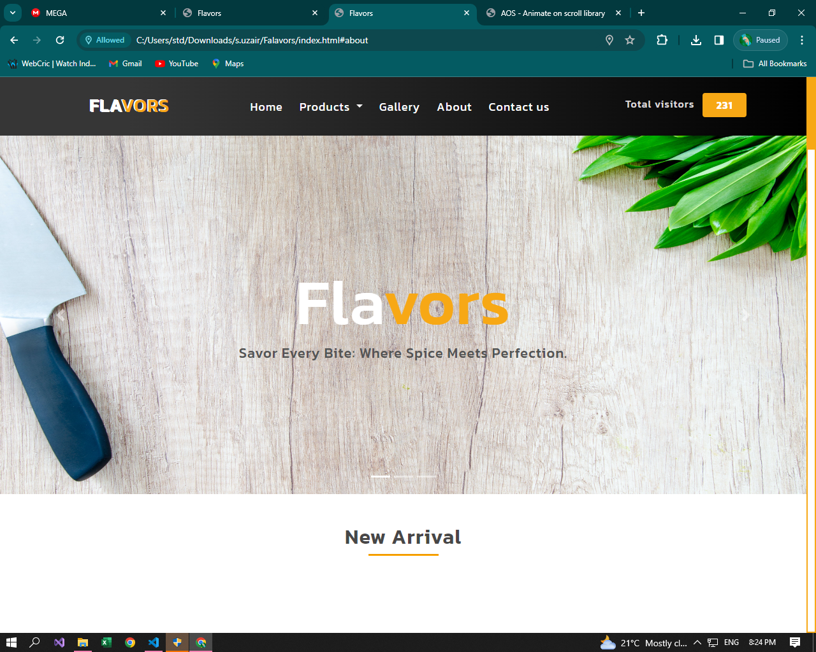

* This is the home page with three sliders of Images that represented our brand when user open the website.

**How to use home page:**

Basically, home page is divided into two main parts:

1. New arrivals.
2. Best seller.

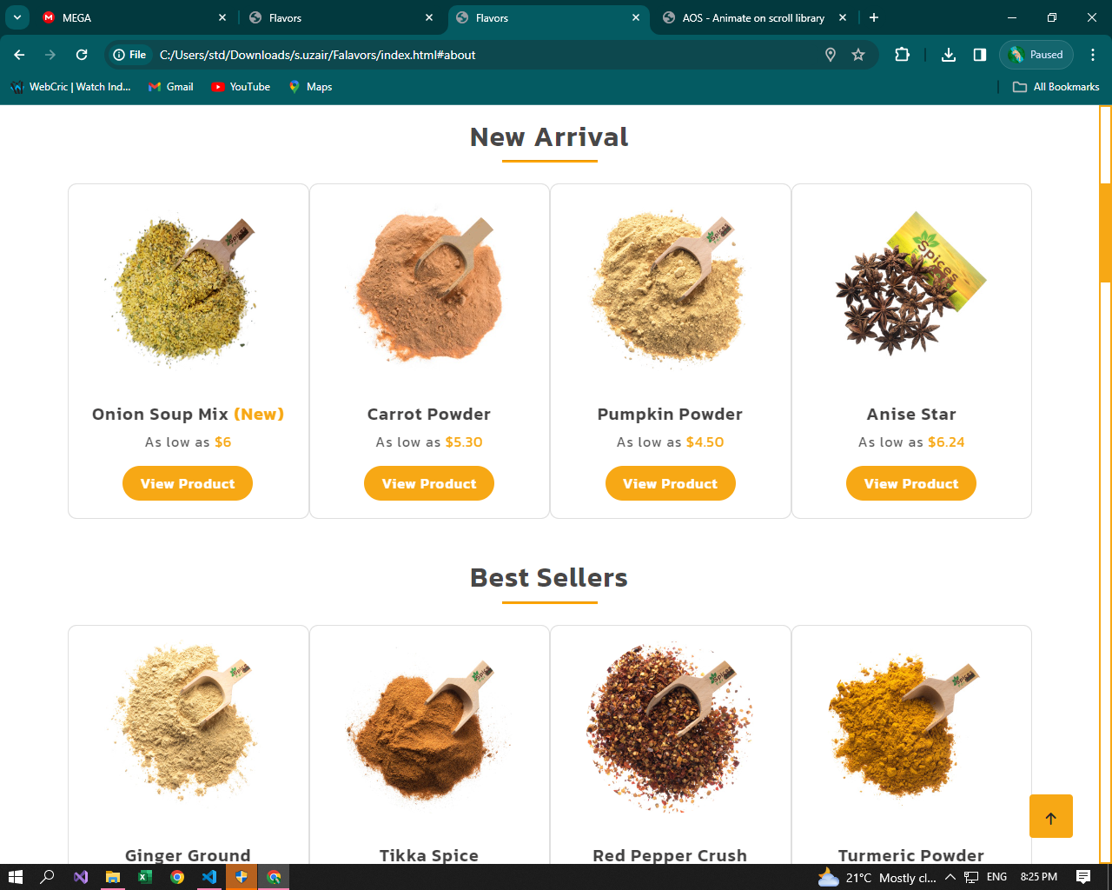

* This is our best seller and new arrivals
* **Products**

Product section contains all our spices and mixes in it.

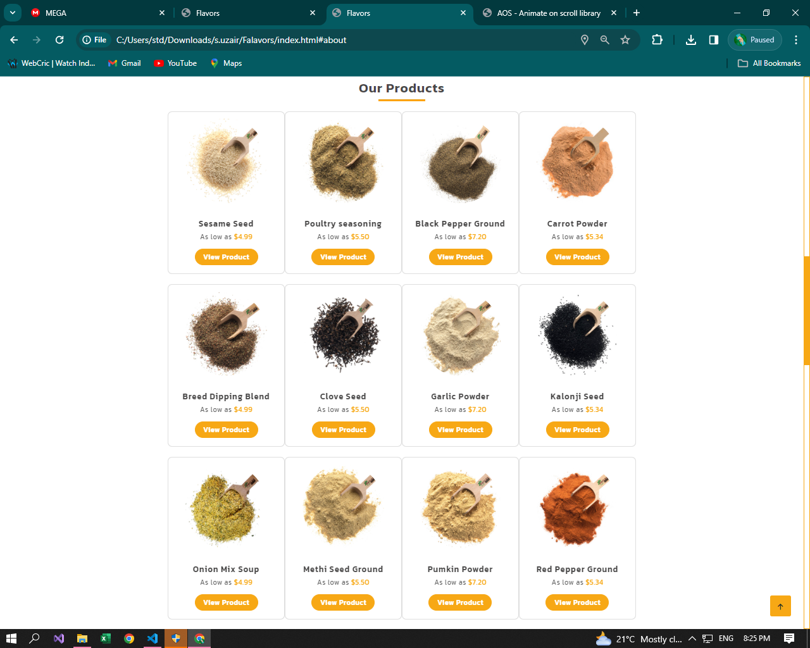

* Here you can find our all spices and mixes.
* **Gallery**

In gallery you can find images of our spices and mixes.

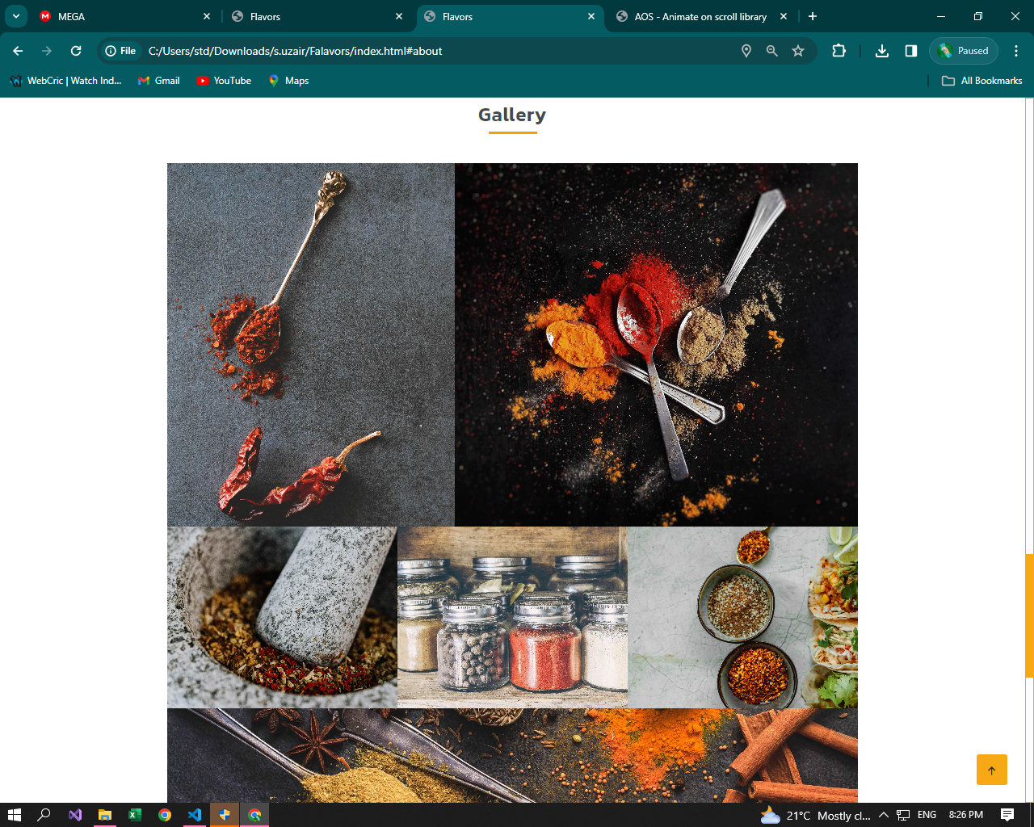

* **About us**

In this section you can know us and what we do with or spices and mixes.

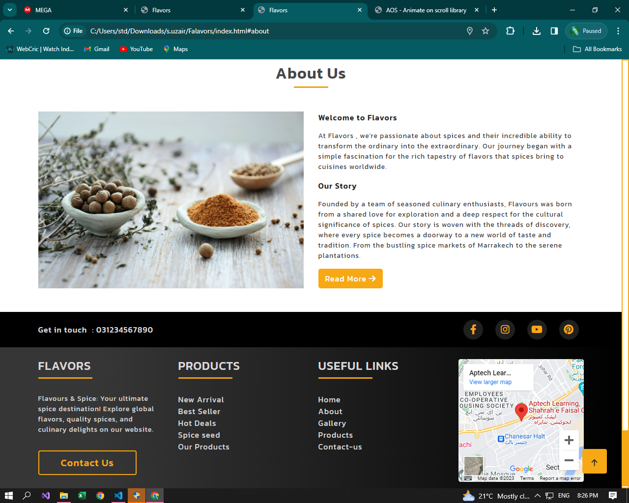

* **Contacts us**

In this section you can write as a review and we can send you updates by email on daily basis.

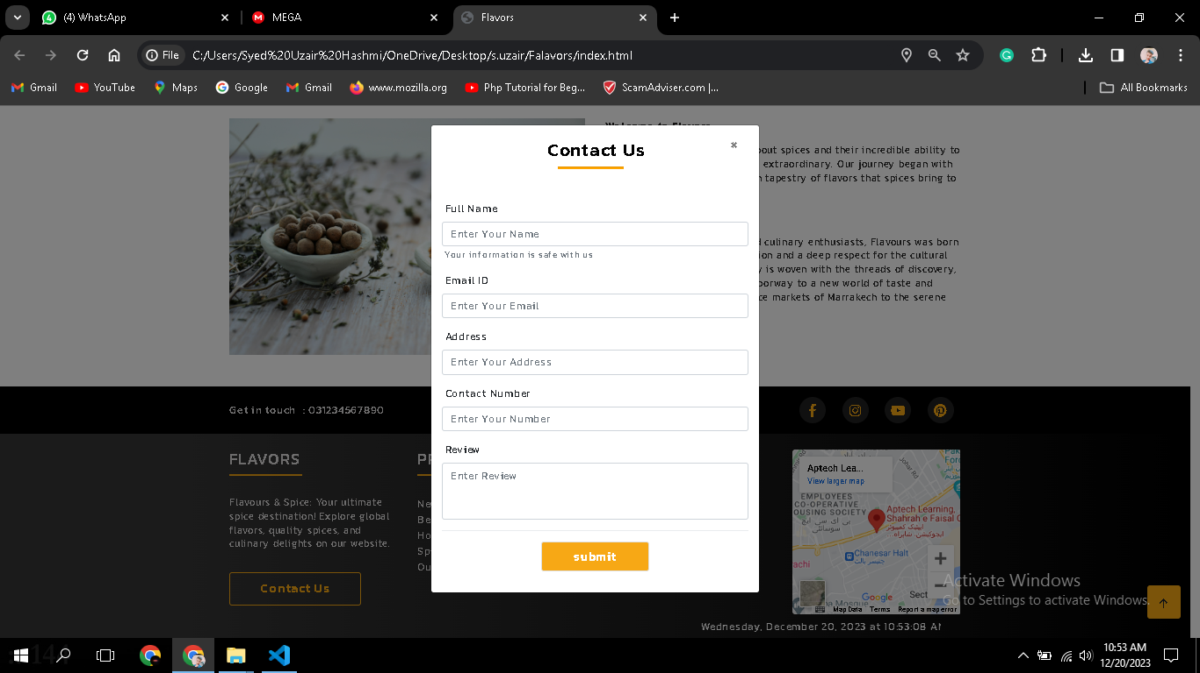

* **Footer**

Our footer is divided into four parts, **links, quick links contact** quick links are hyperlinked from where you can navigate from one page to another page. And also, you can connect with us on Social media.

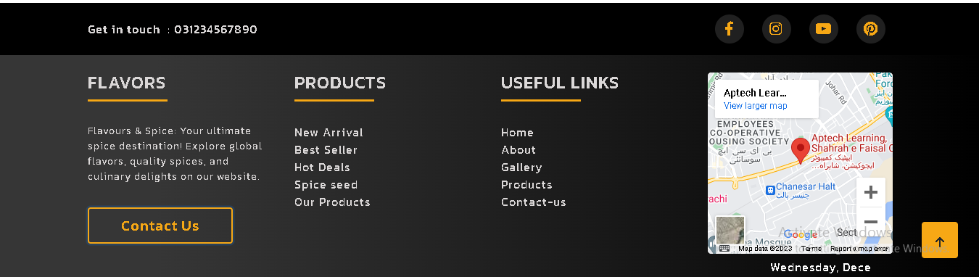

**Home Page Source Code:**

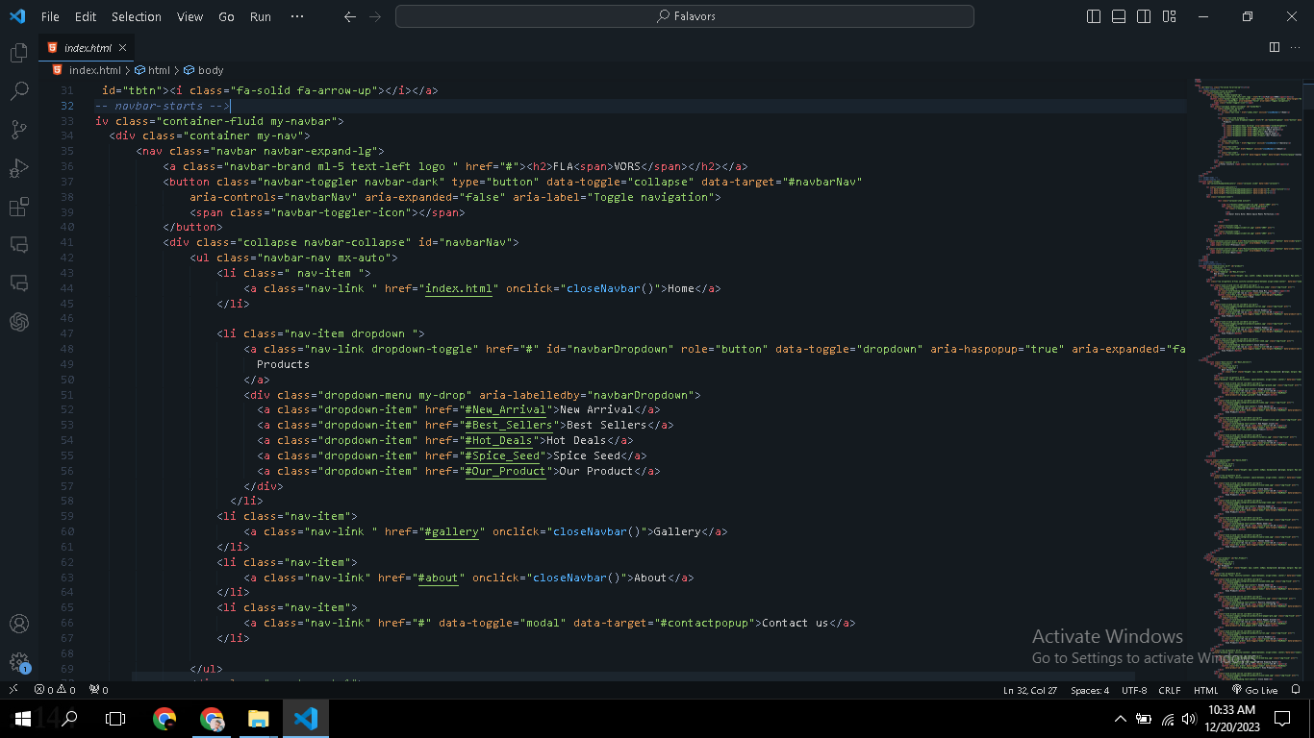

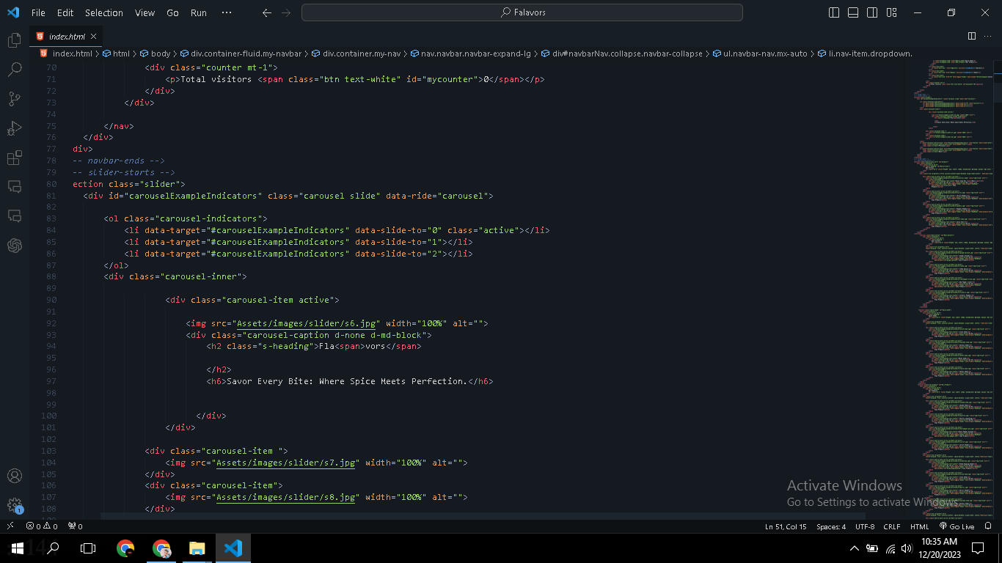

**Product Page Source Code:**

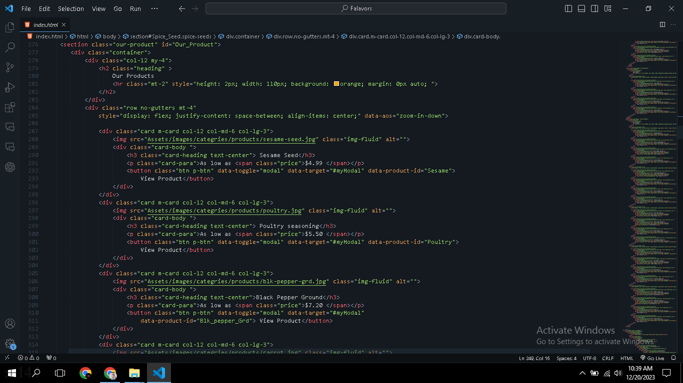

**Gallery Page Source Code:**

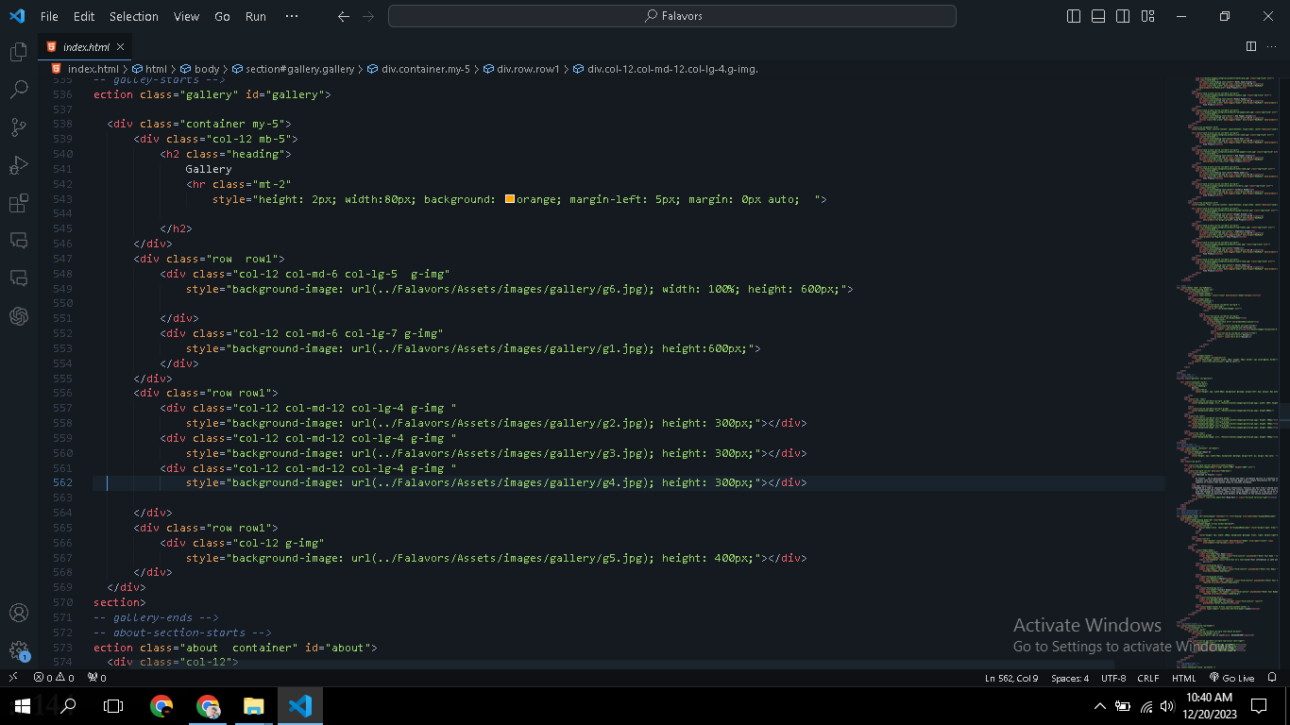

**About us Page Source Code:**

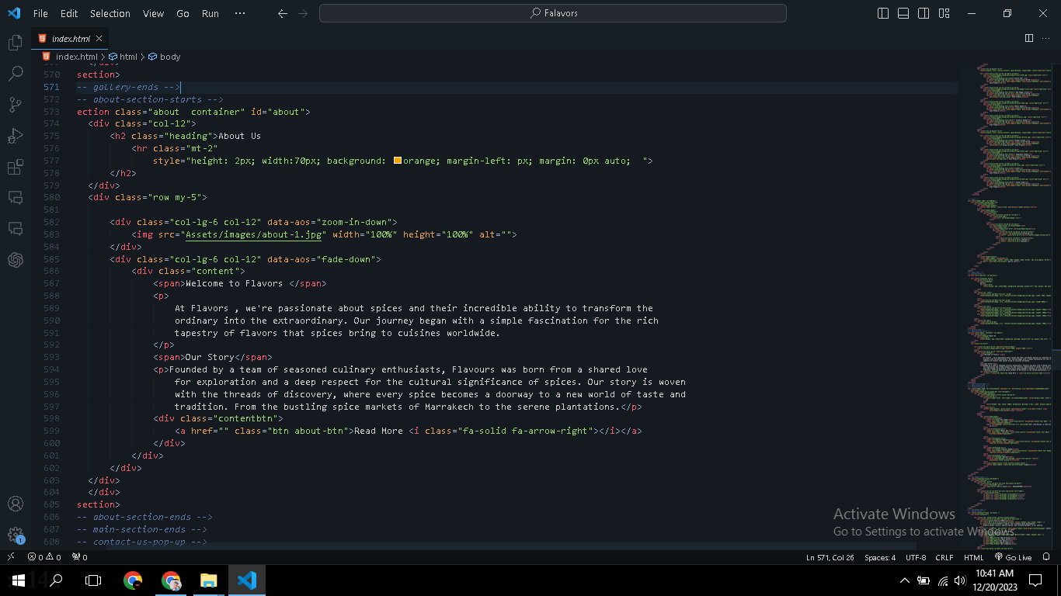

**Contact us Page Source Code:**

